1. **Career-A-Thon**
   1. It's derived from "**marathon**," a long-distance running race.
   2. **A-Thon**: Event that is intensive, prolonged, focused on a specific goal.
2. This is Weekly-Inner-Circle call. Weekly Community Call.
3. Why do we catch up here every week and work through a process? 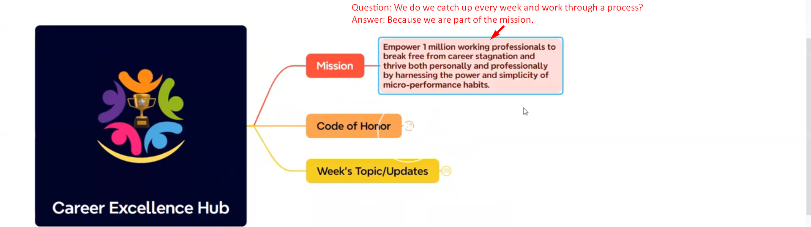  
   It is not only about survive but thrive and take our game to the next level.
4. **Question**: How are we going to be the **flag bearer** **of this mission**?
5. **Answer**: We are going to do this with 6 Code of Honors.
6. Code of Honors:
   1. **Leadership**: In the current context, it means how we rehumanize leading anyone whom we interact with maybe within our family or the circle of influence or at work.  
      Nowadays, interactions are becoming more and more digital and it means that how **to rehumanize our interactions**.
   2. **Self-Disciple**:
   3. **Impact**: Not just being busy, doing what actually creates positive impact in our life and career.
   4. **Legacy**: Rome is awesome city (One of the Wonders of the World). It was not built in a single day.   
      We can build our legacy one day at a time. That is why we meet every Monday at 7:30 to plan our week and then we start off on a positive note.  
      That is the way we build legendary week which compounds to legendary month that compounds to legendary Quarter, year and one day we realize that hey I am living Legendary Life.
   5. **Growth**: We are here to navigate through the challenges that life throws on us. If we are not growing, we become **stagnant**.
   6. **Contribution**: 10% of our net income or start with 100/month. It is about creating flow. The more you know how to create the flow, the more you bless the money.  
      So, this is Code of Honors kind of Value System with which we all show up here inside the community.
7. **BIO**: Bring It On.
8. 06:12